Answer 6
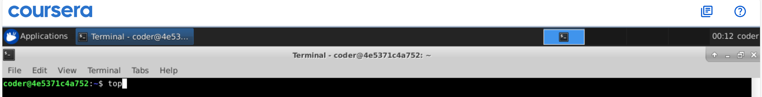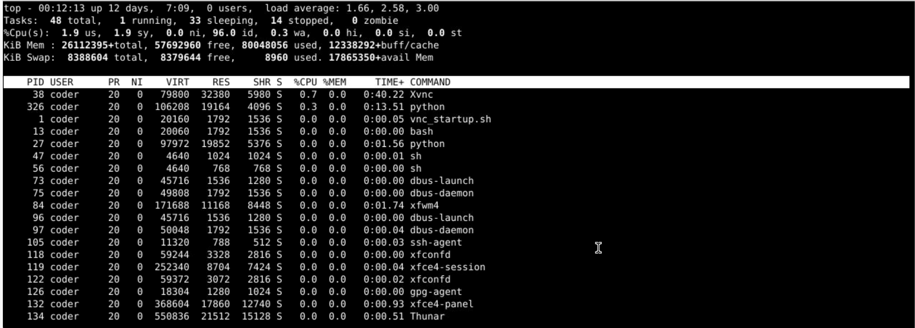
Explanation: There are different ways t check for memory usage, here I am using top command gives the detailed view. In line 4 KiB Mem is the current memory usage. Also top is already in human readable format.

